NICOLE DOBBINS ACTING RESUME
Contact details  Email  LEKEE1@COMCAST.NET  Education  BACHELOR OF SCIENCE in BIOLOGY  UNIVERSITY OF COLORADO  COLORADO SPRINGS, CO  Improv Instruction  HOLLYWOOD SHOWCASE DENVER  SU COFFEY | Agent details  Represented by  BIG FISH TALENT AGENCY  Agent’s phone  (303)744-7170  Bio  Eye Color: BROWN  Height: 5’5  Hair Color: BLACK  Weight: 130 lbs |  | 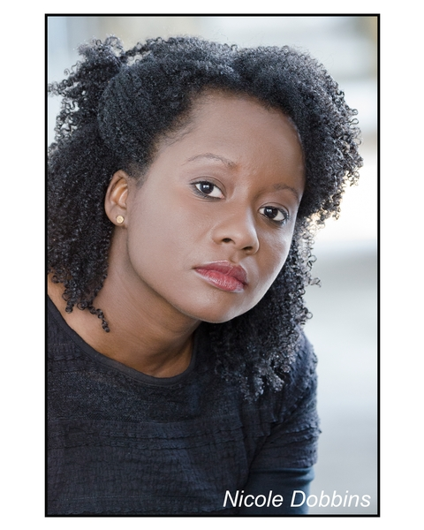
Film & Television Credits
FURNITURE ROW SHOPPING CENTER MEMORIAL DAY COMMERICAL |  | FEATURE
CHICAGO PATHLIGHT COMMERICAL |  | FEATURE
SILK COMMERIAL |  | FEATURE
INTERNATIONAL DELIGHT AND HONEST TO GOODNESS |  | HAND MODEL
HONEST TO GOODNESS-DANONE |  | HAND MODEL
PET FOOD INTERNAL TRAINING |  | FEATURED ACTOR
BJ’S COMMERICAL SHOOT |  | EXTRA
COVID VACCINATION SHOOT |  | EXTRA
SAG FEATURE FILM SHOOT |  | BACKGROUND
UTPP FILM |  | BACKGROUND

Special Skills
Cycling | Roller Blading | Painting
Yoga | Southern Accent | Dance

